WEEK-10--Elastic Beanstalk
Elastic Beanstalk is a Platform as a Service (PaaS) provided by Amazon Web Services that lets you deploy and manage applications without worrying about infrastructure.
Instead of manually setting up servers, load balancers, and scaling:
- You upload your code (Java, Python, Node.js, PHP, etc.)
- Beanstalk automatically:
  - Launches Amazon EC2 instances
  - Configures Elastic Load Balancing
  - Handles scaling (auto scaling)
  - Sets up monitoring with Amazon CloudWatch

When to Use?
Use Elastic Beanstalk when:
- You want quick deployment
- You don’t want to manage infrastructure
- You are building web apps or APIs
Feature | EC2 | Elastic Beanstalk
Type | IaaS (Infrastructure) | PaaS (Platform)
Control | Full control (OS, software) | Limited control
Setup | Manual | Automatic
Scaling | Manual / Auto Scaling setup | Built-in auto scaling
Server Management | You manage everything | AWS manages it
Deployment | Manual (SSH, scripts) | Upload code directly
Learning Curve | High | Low
Use Case | Custom setups | Quick app deployment

Prerequisites
- A web application ready (e.g., .war, .zip, or code) or simple php file

Steps to Create Elastic Beanstalk Application
Step 1: Open Elastic Beanstalk
- Login to AWS Console
- Under Compute section ->Search for Elastic Beanstalk
- Click Create Application

Step 2: Create Application
- Enter Application Name (e.g., MyApp)
- Add description (optional)
- Click Create
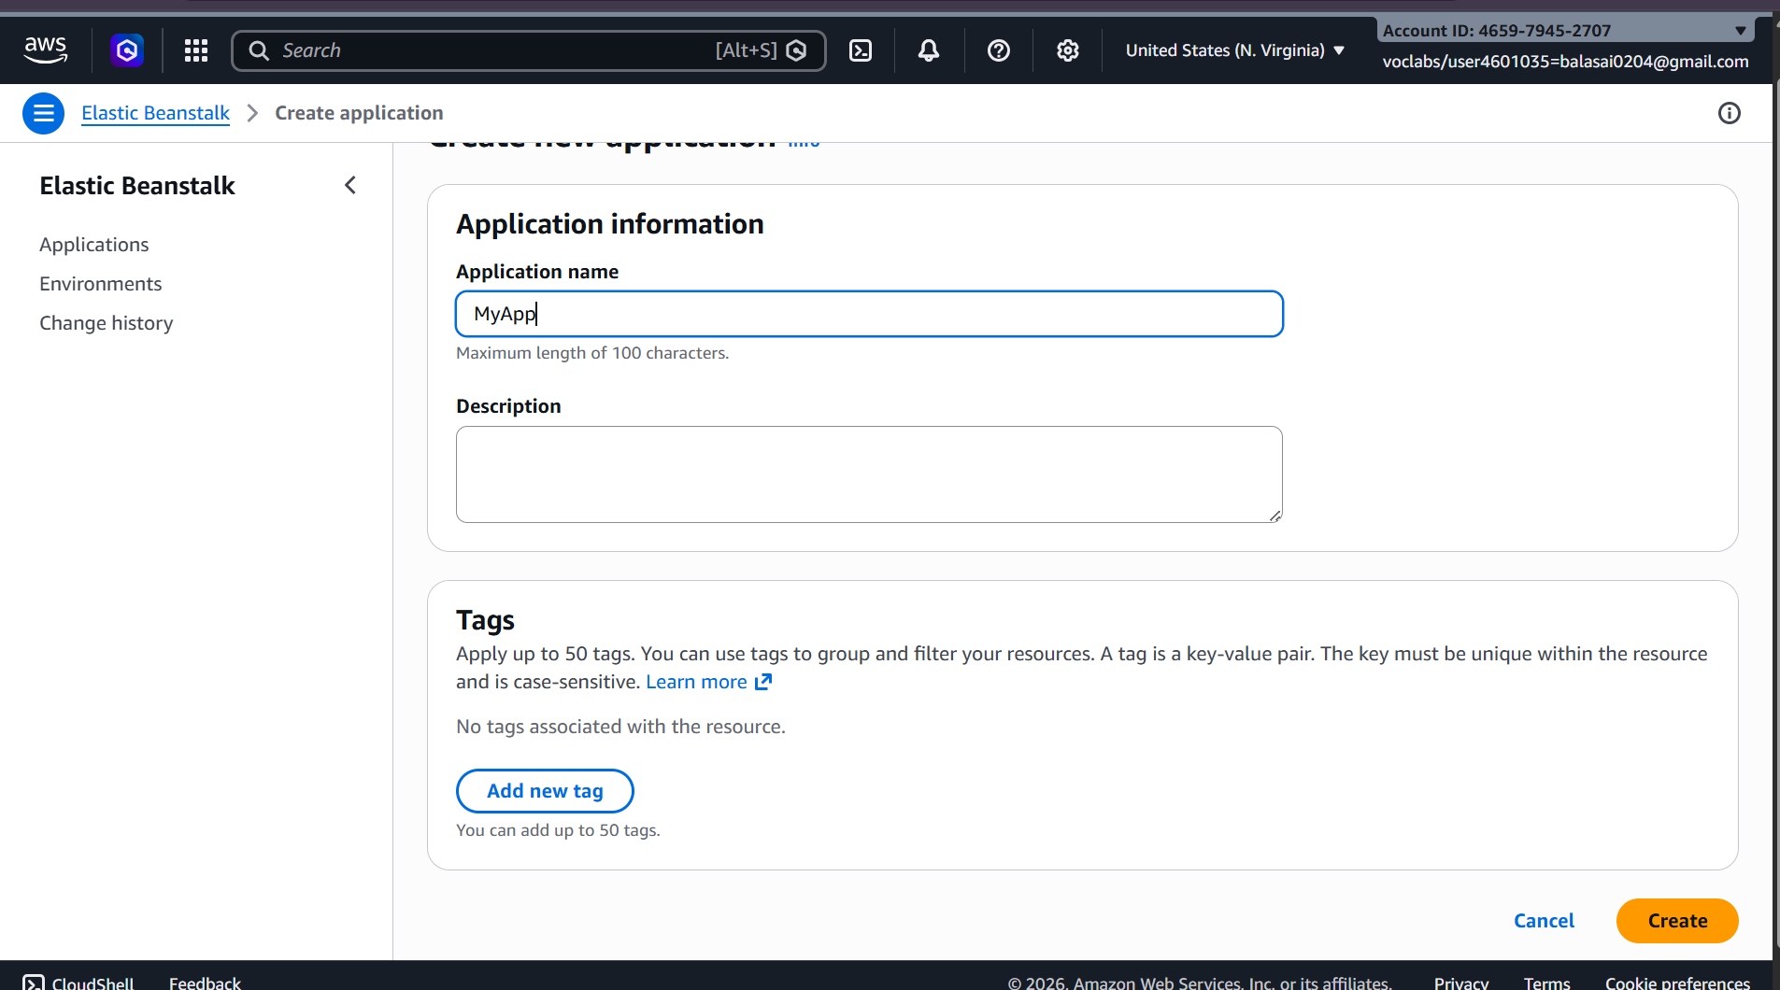

Step 3: Create Environment
- Click Create Environment
- Choose:
  - Web Server Environment (for web apps)
- Click Select

Step 4: Configure Environment
- Enter Environment Name
- Choose Platform:
  - Java (for .war)
  - Node.js / Python / PHP / etc.
- Under Application Code:
  - Select Upload your code
  - Upload your .war or .zip file
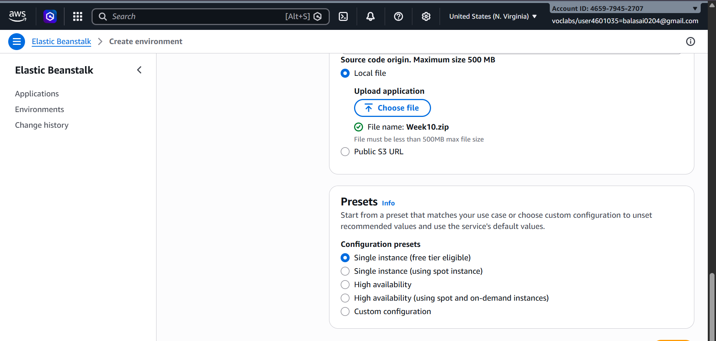

Step 5: Configure Service Access
- Service Role → Select existing -LabRole
- EC2 Key Pair → Optional (for SSH)
- EC2 Instance Profile → select (e.g., LabInstanceProfile)
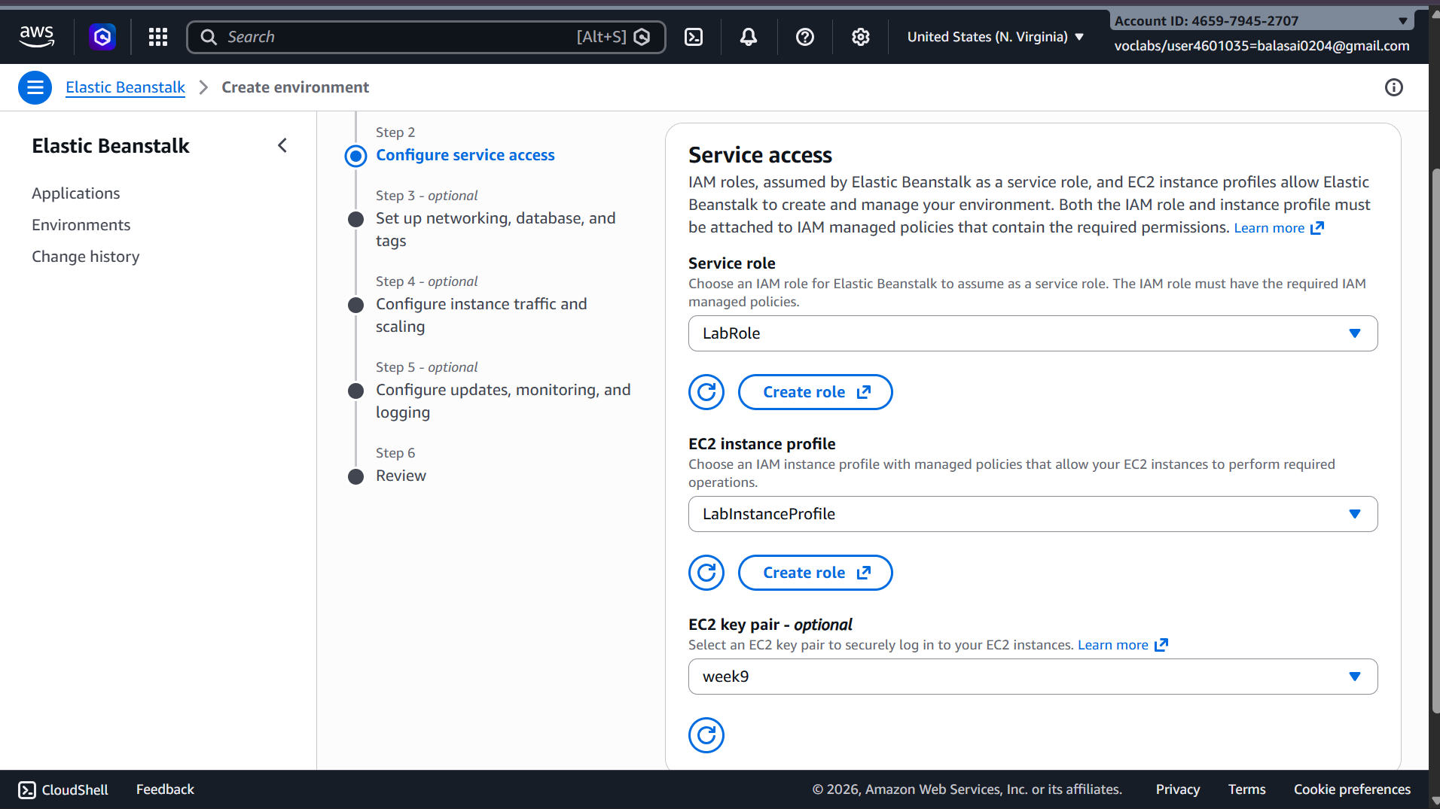

Step 6: Configure Network
- Select VPC (default is fine)
- Select Subnets
- Enable Public IP
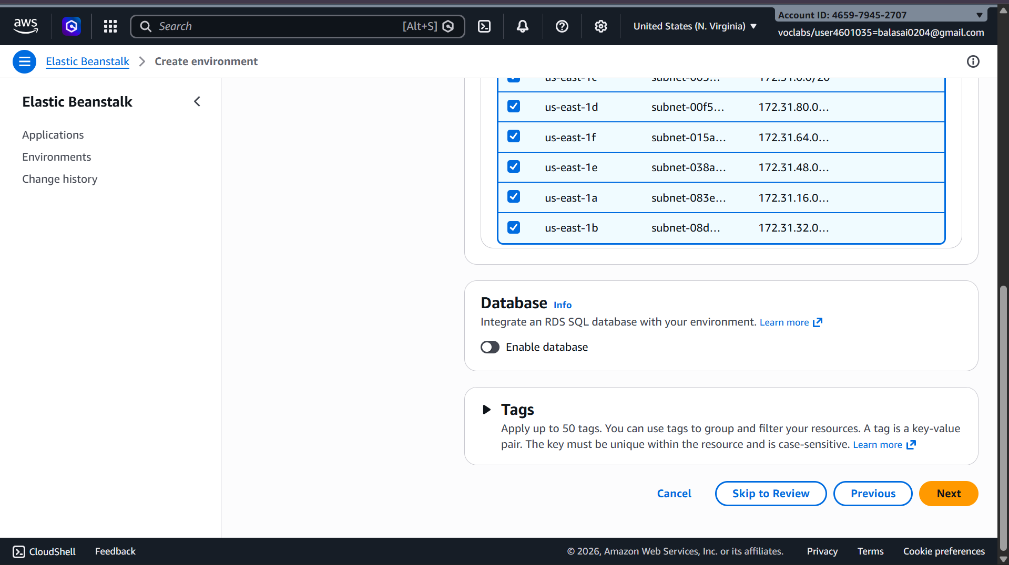

Step 7: Instance & Scaling Setup
- Choose Instance type (e.g., t2.micro – free tier)
- Set:
  - Min instances: 1
  - Max instances: 2 (or more)
- Load Balancer → Enabled (optional but recommended)
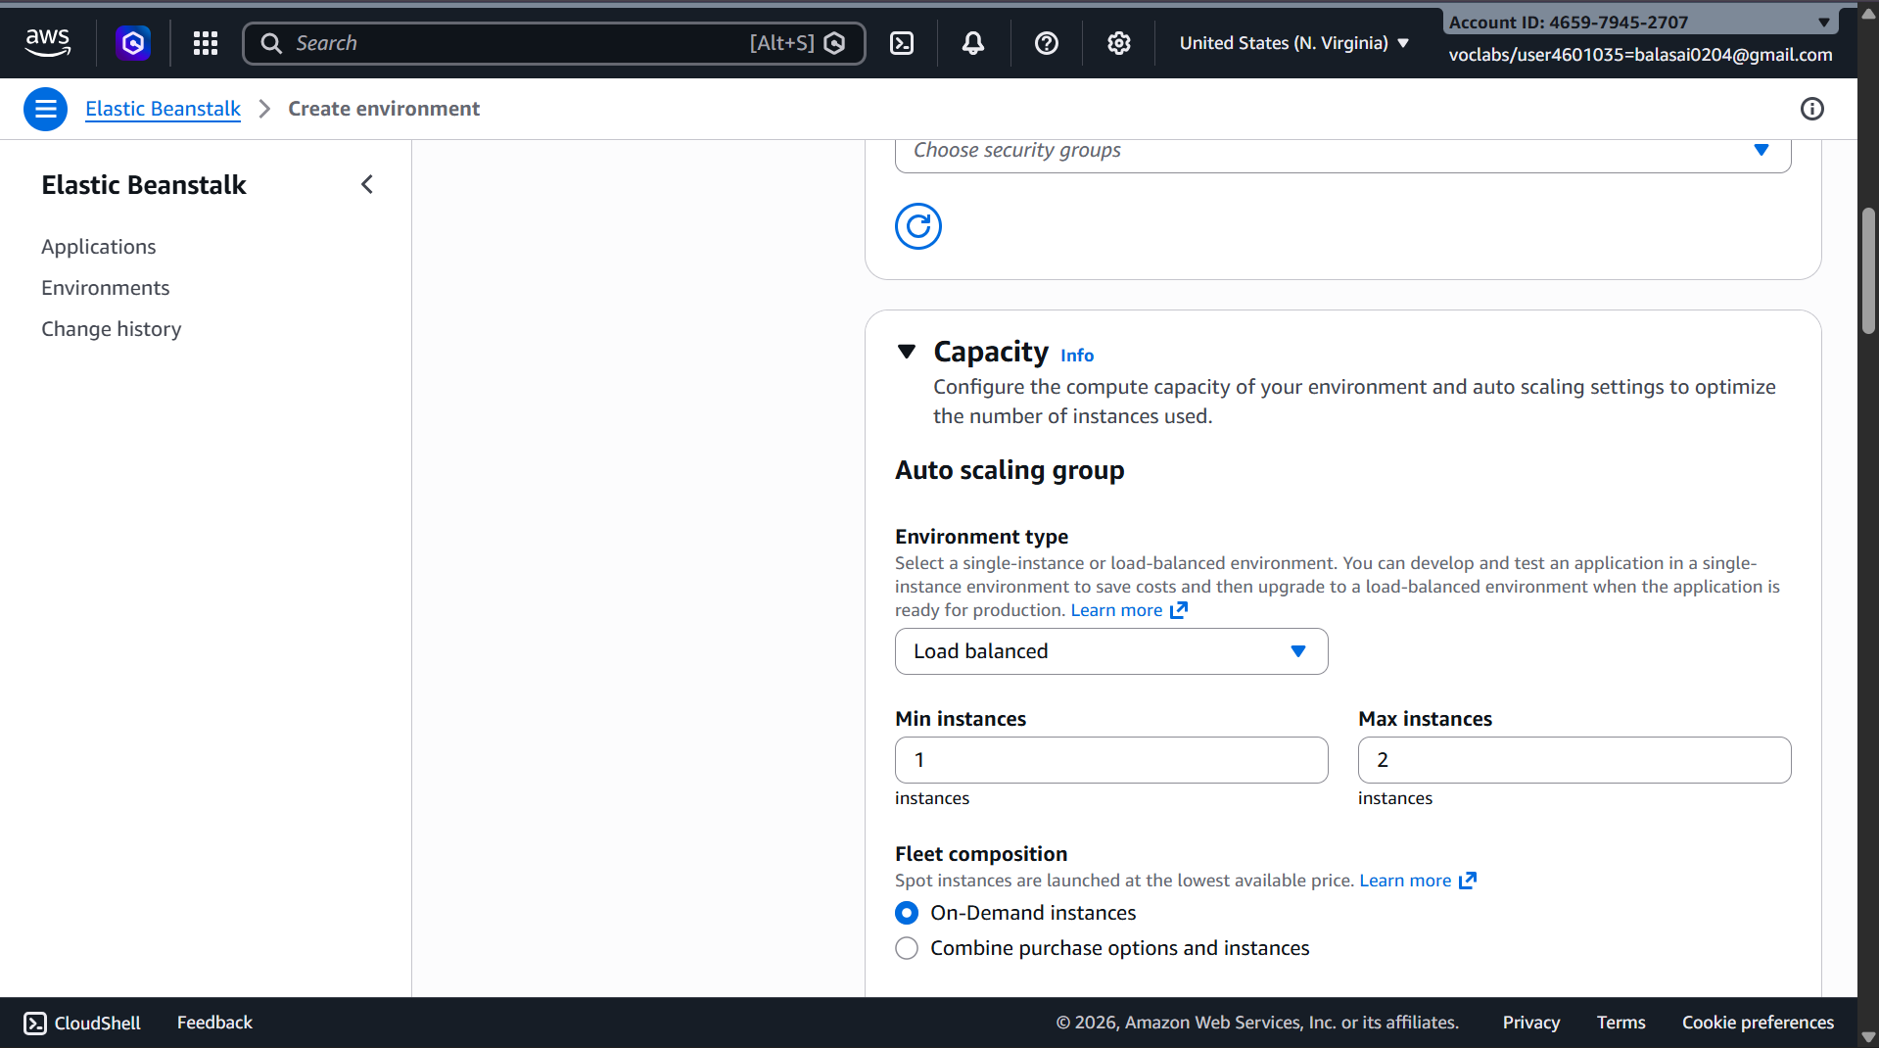

Step 8: Review & Create
- Click Review
- Click Create

Deployment Process
- AWS automatically creates:
  - EC2 instances
  - Load Balancer
  - Auto Scaling Group
  - Security Groups

Access Your Application
- After deployment:
  - You will get a URL (domain link)
  - Open it in browser → Your app will run


Updating Application
- Go to your environment
- Click Upload and Deploy
- Upload new version


Scenario-Based Questions
Scenario 1: Application Not Loading
- Possible reasons:
  - Deployment failure or incomplete deployment
  - Application not running on the correct port
  - Security group blocking HTTP/HTTPS traffic
  - Application crash due to code errors
  - Load balancer health check failure
- Yes, deployment or configuration could be incorrect:
  - Wrong port, missing dependencies, or incorrect environment variables
- Troubleshooting steps:
  - Check Events tab for errors
  - View application logs (stdout/stderr)
  - Verify security group rules
  - Ensure app is listening on the correct port
  - Check instance health

Scenario 2: Incorrect Application Structure
- Application structure is critical because Elastic Beanstalk expects files at the root level
- If files are inside an extra folder:
  - Beanstalk cannot find entry files (app.py, index.js, etc.)
  - Deployment may succeed but app won’t run
- Fix:
  - Repackage the app so all files are at the root of the ZIP
  - Avoid nested directories

Scenario 3: Wrong Platform Selection
- Platform selection is important because:
  - It defines runtime (Node.js, Python, Java, etc.) and environment configuration
- Wrong platform issues:
  - Application won’t start
  - Dependencies won’t install
  - Entry point won’t be recognized
- Fix:
  - Create a new environment with the correct platform
  - Or clone environment and redeploy

Scenario 4: Environment Health Warning
- Possible reasons:
  - High latency or CPU usage
  - Failed health checks
  - Application returning 4xx/5xx errors
  - Instance startup issues
- Check first:
  - Events → recent failures
  - Logs → application errors
  - Metrics (CloudWatch) → CPU, memory, latency
- Resolution:
  - Fix application errors
  - Scale instances if overloaded
  - Correct health check path
  - Optimize performance

Scenario 5: Application Errors in Logs
- Indicates:
  - Runtime errors, crashes, or misbehavior in application
- Possible causes:
  - Missing dependencies
  - Incorrect environment variables
  - Database/API connection failures
- Analysis:
  - Check stack traces
  - Identify failing modules/functions
  - Correlate errors with recent changes

Scenario 6: Deployment Failure
- Possible issues:
  - Incorrect ZIP structure
  - Missing required files (requirements.txt, package.json)
  - Syntax/config errors
  - Unsupported file formats
- Logs to check:
  - eb-engine.log
  - Deployment logs in Elastic Beanstalk
- Impact:
  - Application fails to install dependencies or start
  - Deployment stops midway

Scenario 7: Works Locally but Not on Cloud
- Environment differences:
  - OS differences (Windows vs Linux)
  - Different runtime versions
  - Missing environment variables
- Possible causes:
  - Missing dependencies
  - Hardcoded local paths
  - Incorrect configurations
- Debugging:
  - Compare local vs cloud setup
  - Check logs in Beanstalk
  - Validate environment variables

Scenario 8: Blank Output
- Possible causes:
  - Application returns empty response
  - Runtime errors not crashing app
  - Missing frontend/template files
  - Backend not connected to data source
- Logs help:
  - Reveal silent errors
  - Show request handling issues
  - Identify failed rendering or API calls

Scenario 9: Application URL Not Accessible
- Possible reasons:
  - Environment still launching
  - Deployment failure
  - Network/security restrictions
  - Load balancer issues
- Check:
  - Environment status (Launching/Ready/Error)
  - Events tab for failures
  - Security group and networking

Scenario 10: Resource Management Issue
- Cost implications:
  - Continuous charges for EC2, storage, and load balancers
- Services running:
  - EC2 instances
  - Elastic Load Balancer
  - EBS volumes
  - CloudWatch logs
  - S3 storage
- Proper termination:
  - Terminate environment in AWS Elastic Beanstalk
  - Delete unused resources (S3, logs, snapshots)
  - Verify all services are stopped

